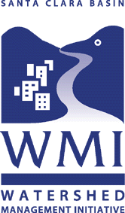

WATERSHED
ACTION PLAN

Executive Summary

AUGUST 2003

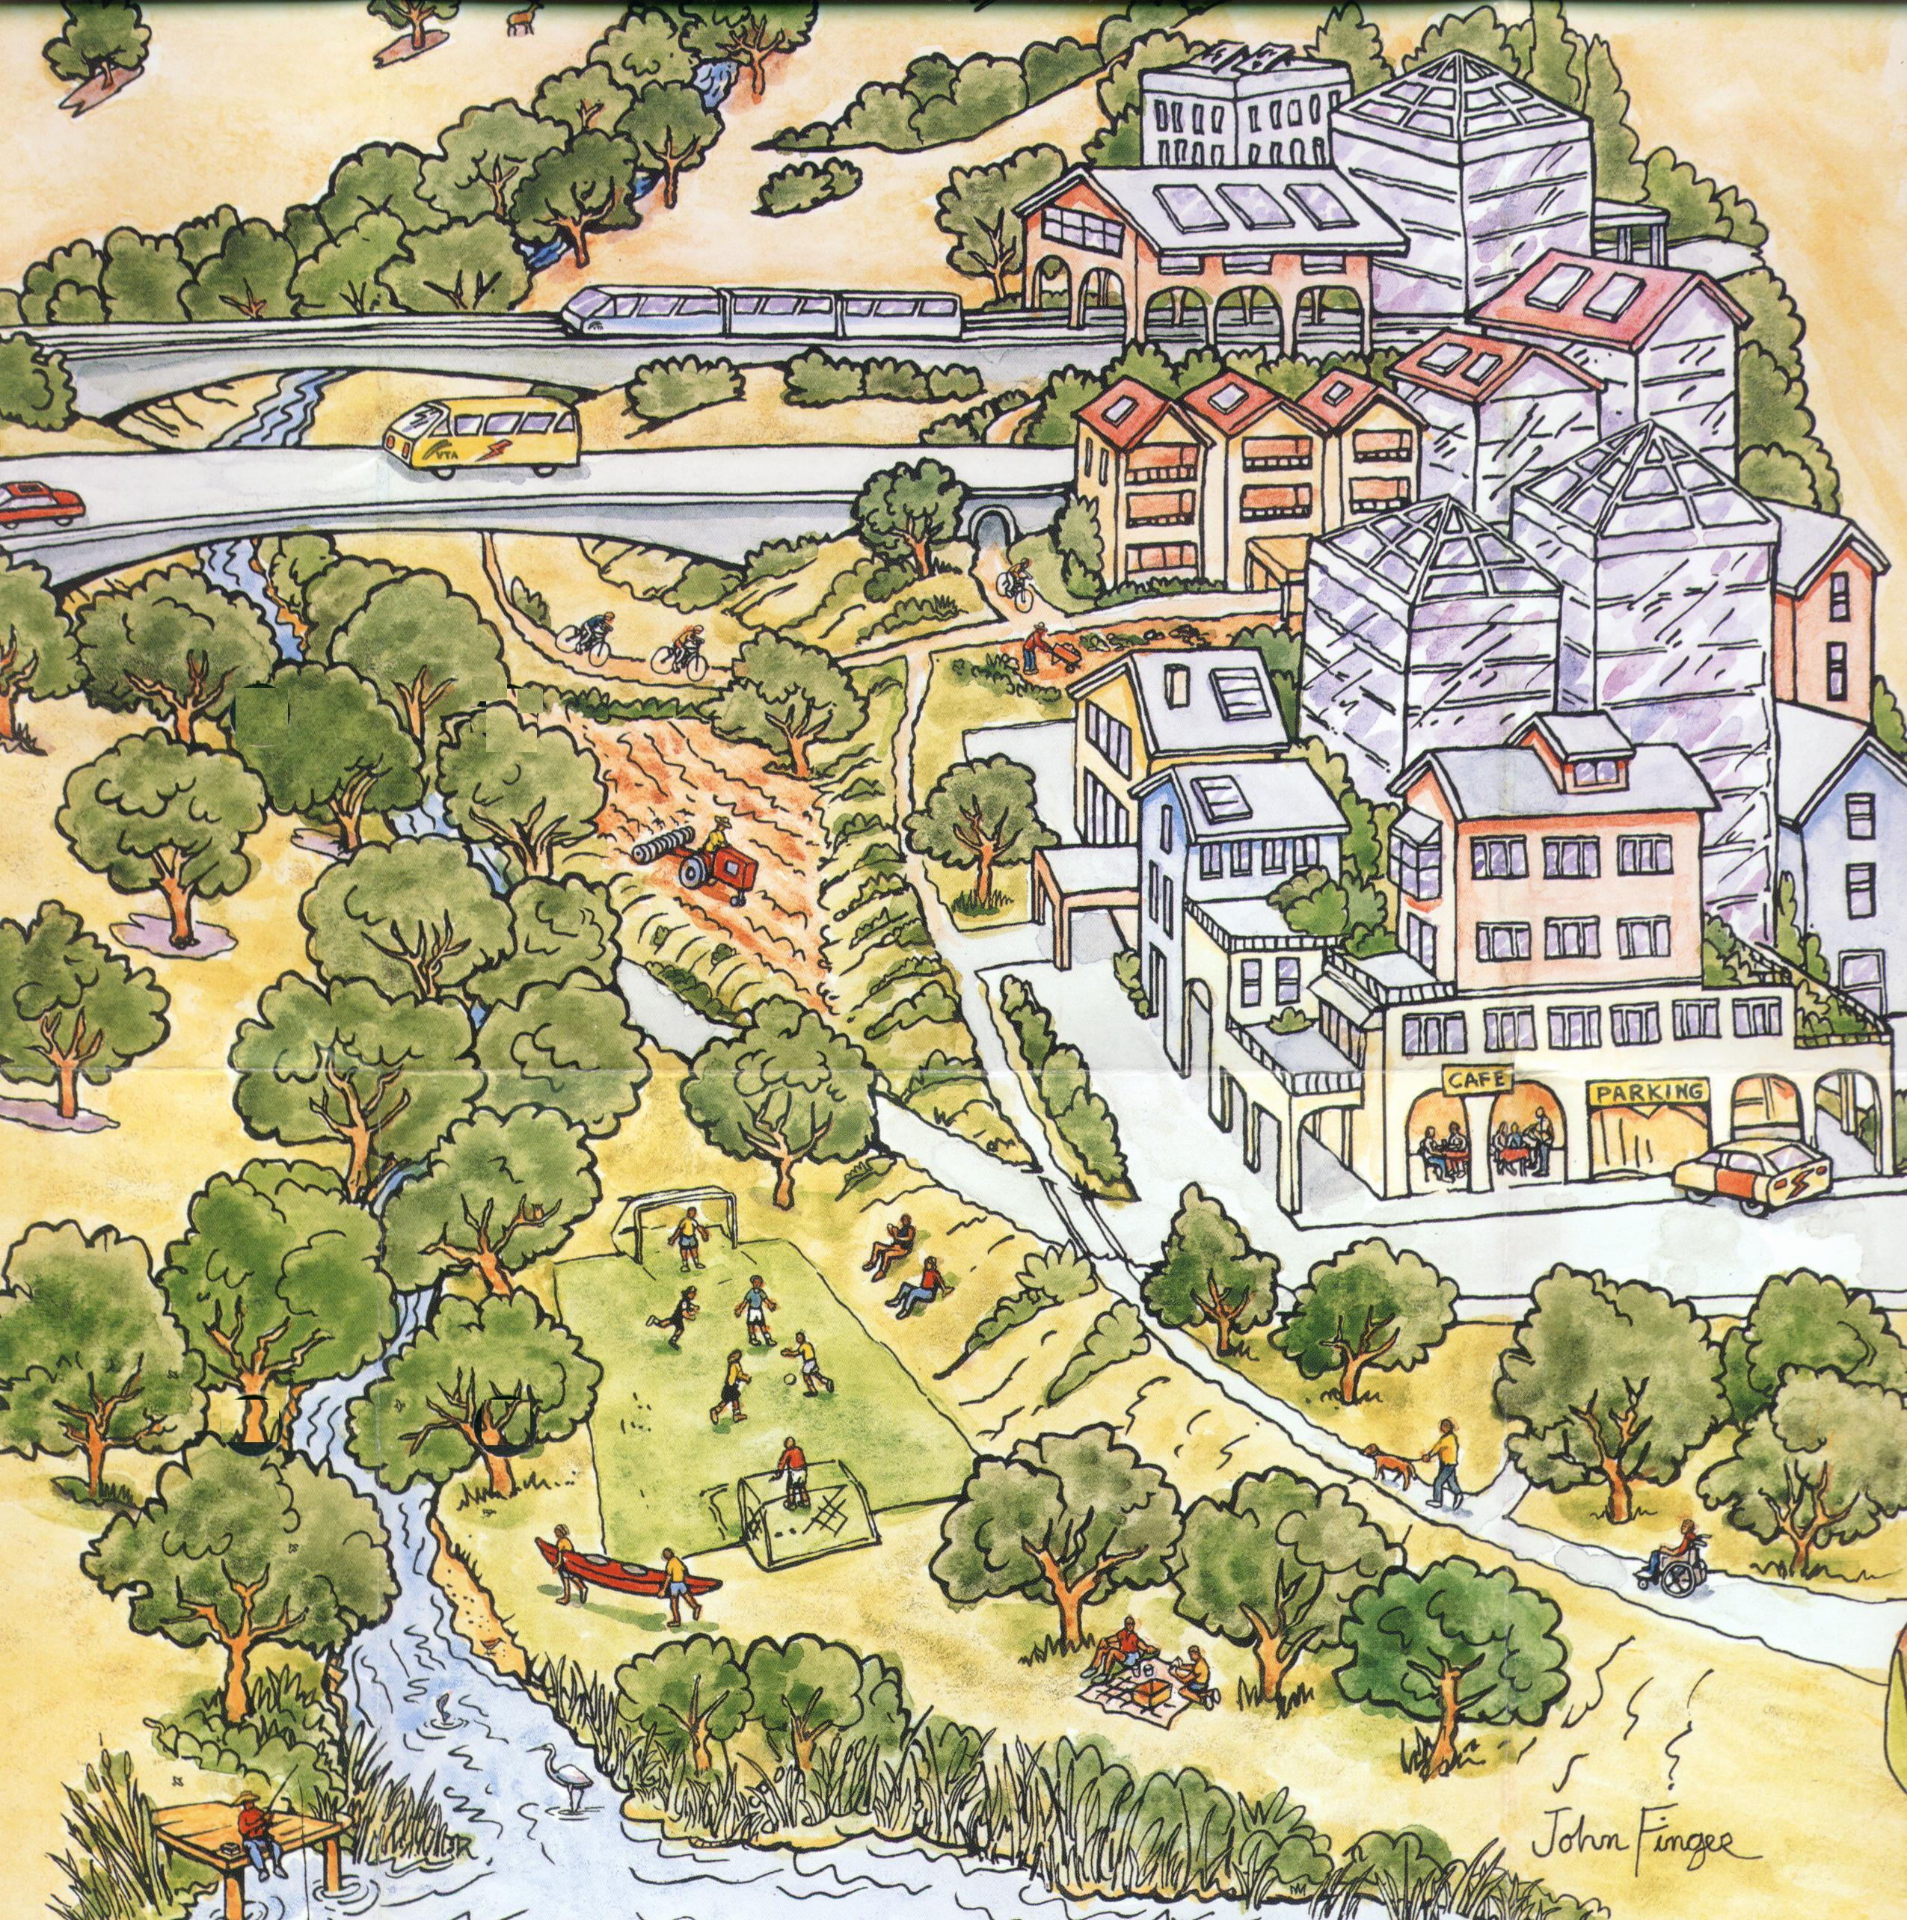
DRAFT
MARCH 2003

EXECUTIVE
SUMMARY
  - The WMI and the Watershed Action Plan
The Santa Clara Basin Watershed Management Initiative (WMI) is a collaborative, stakeholder-driven effort among representatives from regional and local public agencies; civic, environmental, resource conservation and agricultural groups; professional and trade organizations; business and industrial sectors, and the public.
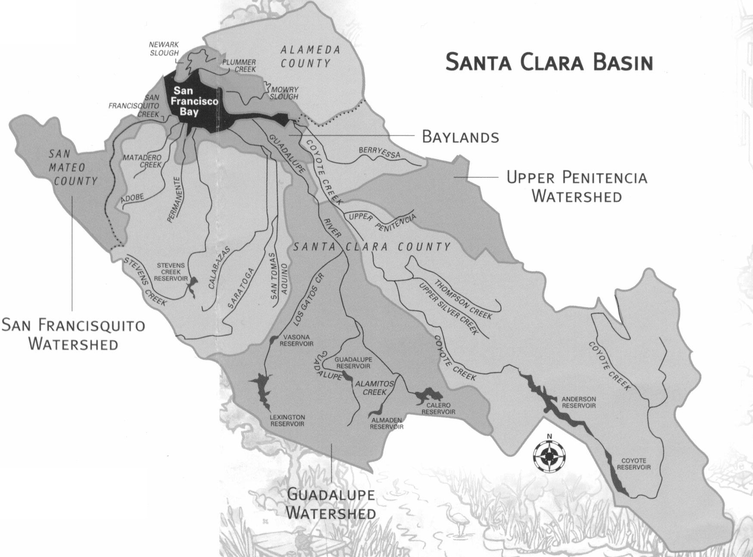
The WMI’s watershed, the Santa Clara Basin, encompasses southern South San Francisco Bay (south of the Dumbarton Bridge) and the 840-square-mile area that drains to it.
The WMI’s mission is to protect and enhance the watershed, creating a sustainable future for the community and the environment.
The WMI’s goals are:
- Ensure that the WMI is a broad, consensus-based process.
- Ensure that necessary resources are provided for WMI implementation.
- Simplify compliance with regulatory requirements without compromising environmental protection.
- Balance the objectives of water supply management, habitat protection, flood management, and land use to protect and enhance water quality.
- Protect and/or restore streams, reservoirs, wetlands, and the Bay for the benefit of fish, wildlife, and human uses.
- Develop an implementable Watershed Management Plan that incorporates science and will be continuously improved.
The WMI’s Watershed Management Plan consists of three volumes:
- A Watershed Characteristics Report, produced in 2000-2001.
- A Watershed Assessment Report, completed in February 2003, which presents the results of pilot assessments conducted in the Guadalupe River, San Francisquito Creek, and Upper Penitencia Creek watersheds.
- This Watershed Action Plan.
To create the Watershed Action Plan, subgroups of stakeholders first developed about 112 “Action Worksheets.” The Action Worksheets defined the WMI stakeholders’ universe of common concerns and represented preliminary consensus on what is to be done to protect and enhance Santa Clara Basin watersheds.
A Watershed Action Plan Technical Advisory Group, composed of stakeholder technical staff, helped prepare the Action Plan.
  - The WMI’s Vision for Santa Clara Basin Watersheds
Mining, forestry, agriculture, and urbanization have radically altered the Santa Clara Basin’s natural resources. However, the streams, rivers, wetlands, and Bay, and the watersheds that drain to them, still support rare species and native ecological communities.
In the coming decades, urban development and redevelopment, upgrades to the transportation system, and flood protection projects will continue to alter and transform Basin watersheds. WMI stakeholders believe this continued change could be managed to sustain economic growth, improve quality of habitat, promote social equity, and enhance natural habitats. Business, society, and government must work together to find ways to balance the needs of water supply, flood management, and habitat protection with needs for housing, recreation, and economic activity.
The WMI envisions a future Santa Clara Basin where:
- Habitat areas stretch contiguously from salt marsh to hilltop, comprising large, connected patches of tidal marsh, continuous riparian forests alongside streams, and buffer areas upland from tidal and riverine wetlands.
- These green corridors separate intensely developed neighborhoods where new and retrofitted buildings, streets, and drainage systems retain or treat runoff.
- Streamside areas are protected from development so that floods can naturally replenish groundwater and sediments without damaging homes and businesses.
- Water is used and reused efficiently, so that there is enough for homes and gardens and industries and also enough to support the natural seasonal cycles of stream and wetland habitats.
- The Basin’s diversity of habitats and species is preserved, riparian and woodland areas are protected and/or restored, invasive plants and animals are controlled, and recreational uses are designed to be compatible with habitat protection.
- Streams flow freely, stream habitats are restored, barriers to fish migration are removed, and native fish species rebound.
- Pollutants do not impair aquatic life, and waters are fishable and swimmable.
A myriad of existing regulations and local government programs are already contributing to each aspect of this vision. However, the regulations and programs grew up one at a time as individual environmental issues emerged. Political systems, like ecosystems, are integrated and interdependent, and many of these programs now overlap. They sometimes even conflict with one another.
Aligning, coordinating, and integrating the funding, staffing, and authority vested in existing environmental-protection programs can accelerate environmental improvements. However, the bureaucratic barriers are daunting. The WMI will focus on finding ways to overcome these barriers.
  - Strategic Objectives and Next Steps for the WMI
The Watershed Action Plan outlines existing environmental-protection programs in each of seven areas and proposes “strategic objectives” for aligning, coordinating, and integrating the programs in each area. The plan also lists “next steps” that the WMI may undertake to promote each strategic objective.
The strategic objectives and next steps follow:
Incorporate the WMI Vision into General Plans and Specific Area Plans (Chapter 3). The WMI advocates that General Plans should incorporate detailed maps and plans to protect and enhance watersheds. Cities, towns, and the County should study obstacles to implementing detailed maps of habitat corridors in General Plans and should consider how to make these maps part of future General Plan updates. Agencies that acquire and manage open space in the Santa Clara Basin should coordinate their individual strategies and link their efforts with General Plans, Habitat Conservation Plans/Natural Community Conservation Plans (HCPs/NCCPs), and floodplain management.
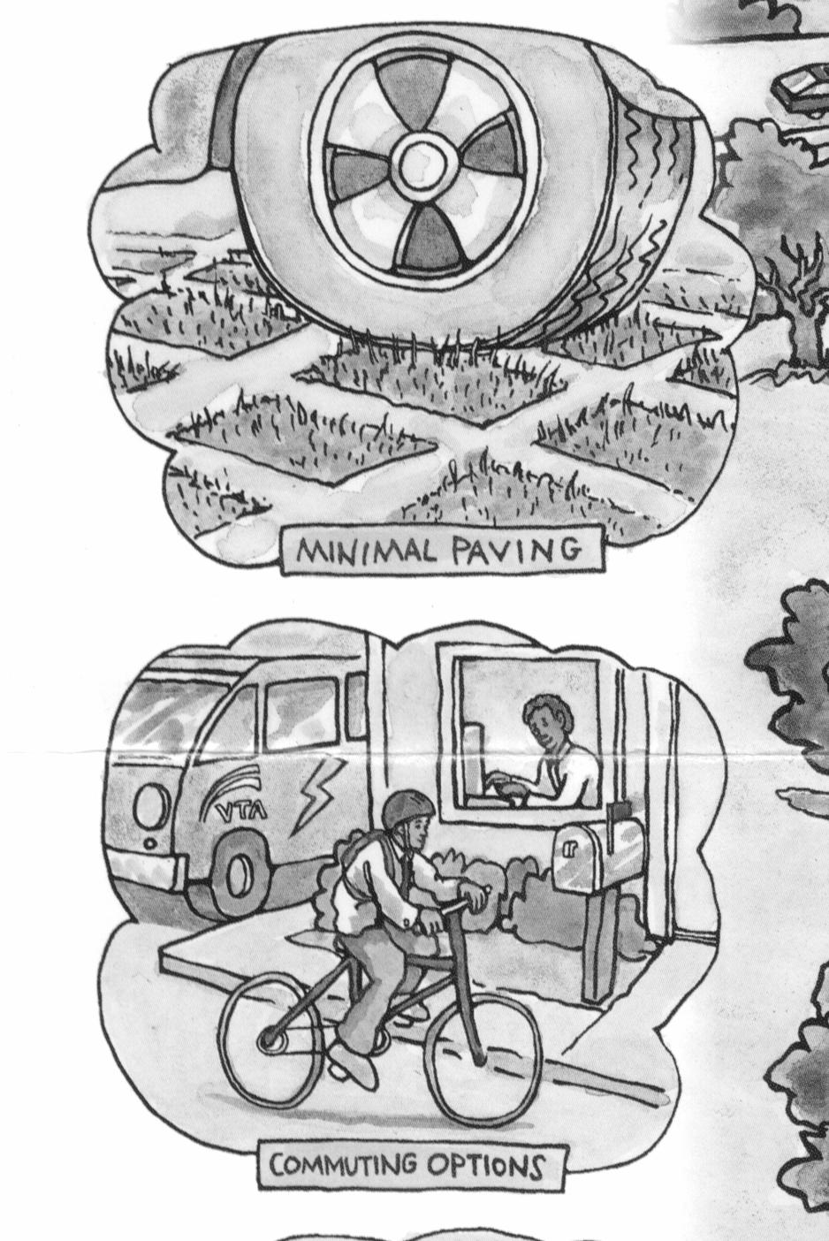
To further this objective, the WMI will:
- Convene and facilitate groups of stakeholders to participate in adaptive management for in-stream projects and programs.
- Convene a dialogue with Planning Commissioners and Directors regarding the use of General Plans and Specific Area Plans to implement, over the long term, the WMI’s vision of continuous habitat corridors and intensely developed neighborhoods.
- Consider, in this dialogue, how to include more detailed watershed analyses in Environmental Impact Reports and balance cumulative impacts with mitigations across jurisdictional lines.
- Join or convene discussions among agencies that acquire and manage open space and work toward strategies for assembling continuous habitat corridors.
- Cultivate alliances with, and bring the WMI’s vision to, “Smart Growth” advocates.
- Research examples where municipalities have used their authority under California’s planning and zoning law to implement watershed-based land-use planning.
- Coordinate and integrate municipal land use planning with other WMI objectives, including riparian and floodplain planning and habitat conservation planning.
- Develop indicators of progress for land-use planning.
Drainage Systems that Detain or Retain Runoff (Chapter 4). The WMI advocates site development designs and drainage system designs that detain or retain runoff where needed to protect streams from flash runoff, erosion and pollutants, and to protect from downstream flooding, while preventing groundwater pollution. Cities, towns, and the County’s standards for site development and drainage systems should encourage practices to minimize runoff entering the storm drain system or waterways. In areas where increased runoff could cause increased erosion of creek beds and banks, siltation, or other effects on streams, new and rebuilt sites and drainage systems should (where feasible) incorporate features to detain or retain runoff.
To further this objective, the WMI will:
- Work with the Santa Clara Valley Urban Runoff Pollution Prevention Program (SCVURPPP) to facilitate implementation of the new NPDES requirements for new development (also known as the “C.3. Provisions”) in the Regional Water Quality Control Board for the San Francisco Bay Region (RWQCB) stormwater discharge permit.
- Review the results of SCVURPPP’s Development Policies Comparison and identify policies that limit detention and infiltration of runoff and potential improvements to policies controlling erosion and sedimentation from construction sites.
- In cooperation with SCVURPPP, develop model public works policies, specifications, and details to encourage detention and infiltration of runoff and to control erosion and sedimentation from construction activities.
- Coordinate and integrate implementation of the guidance manual and other outcomes of SCVURPPP’s hydrographic modification management plans with stream stewardship plans (Chapter 8) and with General Plans and Specific Area Plans (Chapter 3).
- In cooperation with SCVURPPP, distribute model public works specifications and details to municipalities in presentations to managers and public works departments and in workshops for public works staff, developers, and engineering consultants.
- Provide a neutral place where contentious issues relating to drainage design methods and effectiveness can be referred.
- Develop indicators of progress for buildings, streets, and drainage.
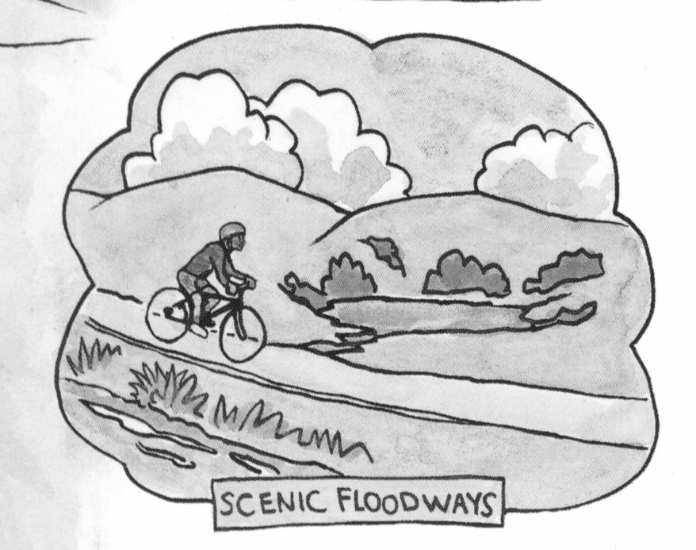
Integrated Planning of Floodplains and Riparian Corridors (Chapter 5). The WMI advocates an integrated planning process to chart the future landscape of the Basin’s floodplains and riparian corridors. The process should incorporate the cities’ riparian corridor policies, the policies and procedures being developed by the Watershed Resources Protection Collaborative, applicable provisions in the cities’ and County’s General Plans, existing and planned recreational uses within floodplains and riparian areas, the Countywide Trails Master Plan and Uniform Interjurisdictional Trail Design, Use, and Management Guidelines, the National Flood Insurance Program, and benefits attainable under the Federal Emergency Management Agency’s (FEMA’s) Community Rating System. The plans should also consider potential habitat for the red-legged frog and other riparian species.
To further this objective, the WMI will:
- Work with the County, municipalities, SCVWD, and other agencies, provide a forum and develop a process for integrated planning of floodplains and riparian corridors.
- Provide a neutral place where potentially contentious floodplain management issues (e.g., protection from flooding vs. floodproofing for specific areas; e.g., location of recreational facilities) can be referred.
- Promote and popularize natural flood protection and floodplain management as a component of the WMI’s vision.
- Develop an outreach strategy that focuses on the multiple uses of stream corridors.
- Coordinate and integrate floodplain and riparian corridor planning with other WMI objectives, including watershed stewardship planning (Chapter 8), habitat conservation planning (Chapter 7), and General Plans (Chapter 3).
- Develop indicators of implementation and effectiveness of multi-use planning for floodplains and riparian corridors.
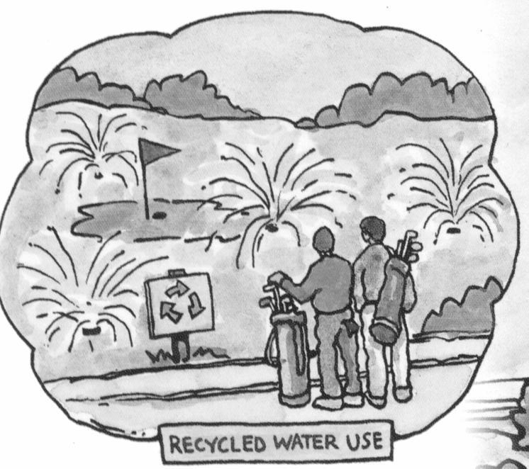
Integrated Water Resources Planning (Chapter 6). SCVWD, San Jose, and the Basin’s other cities and towns should use Integrated Water Resources Planning (IWRP) to focus and coordinate their water conservation and recycling policies and programs. The process should document the many environmental and social benefits of water conservation and recycling – more water to support stream ecosystems in the Santa Clara Basin and statewide, more reliable water supply, and reduced effects of freshwater discharges – and should link these benefits to the overall water supply strategy. Conservation and recycling should be built into projections of future demand that are used for planning potable water supply.
To further this objective, the WMI will:
- Develop broad representation and facilitate efficient decision-making in SCVWD’s IWRP stakeholder process.
- Communicate SCVWD’s IWRP participants’ consensus to agency decision-makers.
- Organize and facilitate outside expertise and technical resources.
- Gauge and build public support for water conservation and recycling.
- Promote water conservation as a component of the WMI’s strategy to protect and enhance Basin watersheds.
- Coordinate and integrate SCVWD’s IWRP with other WMI objectives including watershed stewardship planning (Chapter 8) and habitat conservation planning (Chapter 7).
- Develop indicators of progress toward water supply sustainability.
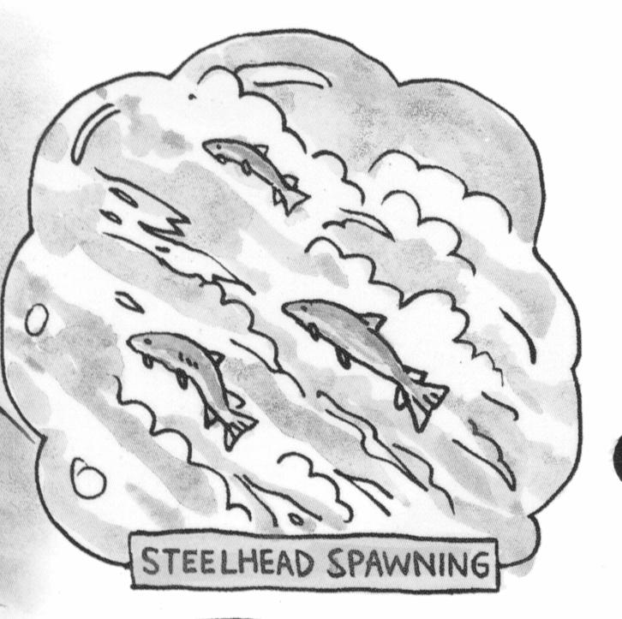
Habitat Conservation Plans/Natural Community Conservation Plans (Chapter 7). The WMI advocates that efforts to protect and enhance habitats for endangered, threatened, and special status species should be focused on creating and maintaining habitat-protected areas. Though Habitat Conservation Plans/Natural Community Conservation Plans (HCPs/NCCPs) have been available as tools for over a decade to help strategically target areas for preservation, they have not been widely used. Some of the early HCP processes had significant shortcomings, such as the lack of "ground-truthed" habitat data, which has led to the improvements the WMI would incorporate in participating in any future HCP/NCCP effort. The plans should begin with updated, improved surveys of species habitats and should incorporate (where appropriate) existing reserves, refuges, parks, and public lands.
To further this objective, the WMI will:
- Convene and facilitate a stakeholder group or groups to participate in scoping HCPs/NCCPs and to participate in adaptive management as plans get underway.
- Join or convene discussions among agencies that acquire or manage open space in the Santa Clara Basin.
- Support efforts to obtain state and Federal funding for the creation of upland habitat preserves identified through the HCP/NCCP process.
- Identify and pursue local sources of funding, including local agencies and foundations, for purchasing and managing critical habitat areas.
- Successfully implement mandated provisions for public outreach and participation in the NCCP process.
- Develop programmatic indicators of progress in implementing habitat conservation plans and a schedule for periodic reporting. Publicize the periodic reports.
- Coordinate the HCP/NCCP with implementation of other WMI objectives/planning processes including planning of floodplains and riparian areas and incorporation of watershed objectives into General Plans and Specific Area Plans.
Expanding the Don Edwards San Francisco Bay National Wildlife Refuge (DESFBNWR) (Chapter 7). The WMI advocates a comprehensive, integrated, stakeholder-based planning process for expanding the refuge. Permits should be issued timely and allow for flexibility and adaptive management to successfully convert salt ponds while allowing reasonable protection to South Bay water quality. The need to selectively maintain levees to manage potential flooding of urban areas should be addressed in a way that balances the objectives of habitat restoration and flood protection.
To further this objective, the WMI will:
- Convene a stakeholder group to track, discuss, and resolve obstacles to enhancing habitat while protecting water quality and protecting urban areas against flooding.
- Seek and endorse broader agency involvement, support, or appropriations necessary to successful habitat restoration.
- Develop indicators of implementation and effectiveness of the refuge expansion and habitat restoration.
- 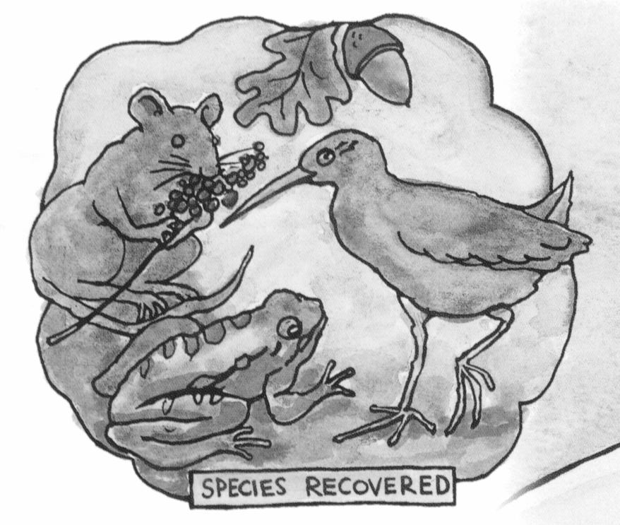Coordinate and integrate refuge planning with other WMI strategic objectives, including multi-objective stream restoration projects (Chapter 8), habitat/natural community conservation (Chapter 7) and incorporating watershed objectives into General Plans and Specific Area Plans (Chapter 3).
- Encourage support for public education and interpretive facilities at the DESFBNWR and other public lands and wildlife refuges.
- Support efforts to obtain state and Federal funding (through CalFed and other programs) to support expansion of the DESFBNWR.
Integrated multi-objective planning and adaptive management for in-stream projects and programs (Chapter 8). The WMI advocates that SCVWD should continue to develop and improve the Watershed stewardship planning process that was recently applied to Coyote Creek. SCVWD should extend this process to other Basin watersheds. The plans should integrate and balance flood protection with habitat restoration and should also integrate floodplain management. The adaptive management process should seek alternatives that minimize expensive and failure-prone areas in-stream structures and, where possible, restore stream-floodplain connections and expand the overall area that is flooded. Floodplain management strategies, such as controlling development and raising and floodproofing structures, should be used to minimize potential damage.
To further this objective, the WMI will:
- Convene and facilitate groups of stakeholders to participate in adaptive management for watersheds.
- Communicate adaptive management participants’ recommendations to decision-makers in SCVWD and other agencies.
- Organize and facilitate outside expertise and technical resources to supplement SCVWD staff expertise.
- Determine the potential for using stakeholder involvement in watershed stewardship planning and multi-objective project planning as a springboard for more permanent local stakeholder involvement.
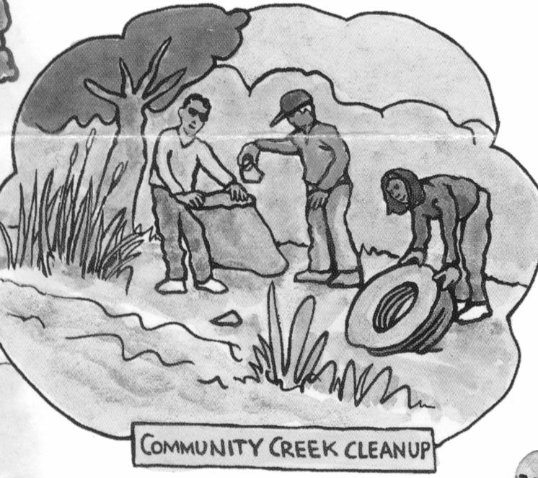
- Sponsor and support applications to fund the stream stewardship process.
- Refine and detail the WMI’s watershed vision and communicate to decision-makers and the public. In WMI outreach publications, promote an understanding of geomorphic and habitat functions and how they are affected by urbanization.
- Coordinate watershed stewardship planning with other WMI objectives, including floodplain & riparian corridor planning, habitat conservation planning, and TMDLs in streams.
Better Assessments, TMDLs, and Discharge Permits (Chapter 9). The WMI advocates that water-quality assessments, TMDLs, and discharge permit requirements should be coordinated through stakeholder processes that support long-term planning and regulatory stability. The RWQCB, SCVURPPP, SCVWD, United States Geological Survey, the municipalities, the Clean Estuary Partnership, and other agencies should coordinate and (where it makes sense to do so) integrate their monitoring and assessment activities. The agencies should envision monitoring and assessment as one component of an iterative process that includes planning, doing, checking, and adapting.
To further this objective, the WMI will:
- Continue and build on the WMI’s successful collaborative processes that led to the 1998 adoption of uncontested discharge permits for the three wastewater treatment plants that discharge to southern South San Francisco Bay and to the 2002 adoption of site-specific objectives for copper and nickel.
- Continue to develop assessment methodologies based on “lessons learned” from the assessments of the San Francisquito, Guadalupe, and Upper Penitencia watersheds and from the forthcoming SCVURPPP assessment of the Coyote watershed.
- Coordinate assessment results and data from TMDLs and other mandated studies with other WMI objectives, including watershed stewardship planning, expansion of the national wildlife refuge, and habitat conservation.
- Prepare annual reports updating key indicators of watershed health and describing recent progress in preserving and enhancing Basin watersheds, new findings and study results, and WMI achievements and successes. (Consider the annual “Pulse of the Estuary” report as a model.)
  - WMI’s Role in Managing Santa Clara Basin Watersheds
The WMI foresees that the process of aligning, coordinating, and integrating environmental-protection programs will take a long time and will be achieved through education, communication, negotiation, and trust-building.
WMI participants acknowledge each other’s legitimate perspectives and interests and share consensus on a balanced approach to environmental protection that streamlines regulations and benefits the regional economy.
WMI participants continuously improve their common, interdisciplinary understanding of watershed science, including geomorphology, ecology, pollutant fate and transport, land-use policy, tax policy, land-development economics, and urban design. As the WMI continues, it is able to apply that expanded knowledge to help develop solutions to emerging environmental issues.
This process of investigating, educating, sharing information, and opening up discussion is what the WMI does best.
In summary, the WMI is laying the groundwork for adaptive management of Santa Clara Basin watersheds. Adaptive management is the process of implementing policy decisions as scientifically driven management experiments that test predictions and assumptions in management plans, and using the resulting information to improve the plans.
The WMI will focus on three general tasks:
- facilitating stakeholder processes.
- bringing recommendations to decision-makers.
- educating and involving the public.
The WMI will continue to advance long-term stakeholder collaboration and information sharing and, at the same time, will support stakeholder work groups dedicated to TMDLs or other specific and current regulatory and environmental issues. The WMI will be an ongoing stakeholder forum to which contentious issues can be referred. The WMI will continue to emphasize the interconnectedness of watershed issues and will look for ways to align, coordinate, and integrate programs, policies, and actions.
The WMI will continue to develop consensus recommendations on what agencies, organizations, and individuals can do to help protect and enhance Basin watersheds. These recommendations will include grant applications and requests to fund watershed projects. The WMI will communicate these recommendations to commissions and advisory committees as well as to the Councils and Boards of public agencies.
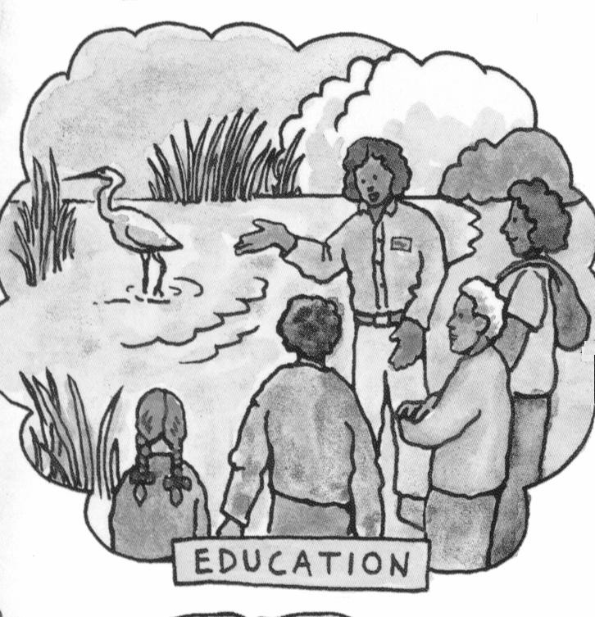
The WMI will encourage its stakeholders to align and coordinate their messages in a way that promotes the WMI vision. The WMI will help stakeholders promote the WMI vision by:
- Developing, updating, and refining a message to popularize the WMI’s approach to preserving and enhancing Basin watersheds.
- Bringing this message to advisory boards, environmental commissions, planning commissions, and other venues for public input to agency decision-making.
- Assessing the need for, and feasibility of, watershed councils in each watershed.
- Linking watershed issues and outreach to community organizations such as homeowners associations and groups that are established or supported in connection with municipal improvement efforts (e.g. San Jose’s Strong Neighborhoods Initiative).
- Helping to coordinate input to, and distribution of, outreach newsletters published by agencies and community groups.
- Bringing the WMI’s perspective on watershed management to K-12 environmental education curricula.
- Encouraging and assisting agencies to incorporate interpretive and educational features as part of recreational facilities and other public works projects (particularly those in the floodplain or that otherwise relate to streams or wetlands).
- Developing, in cooperation with stakeholders, an annual report updating key indicators of watershed health and describing recent progress in preserving and enhancing Basin watersheds, new findings and study results, and WMI achievements and successes.
  - Conclusion
Ecosystems are integrated and complex; social, legal, and political systems are also integrated and complex. These systems are in constant change, and change each other. Successful intervention follows from a common understanding of how our social, political, and natural environments interact.
This Action Plan is one step in the journey toward that common understanding.

