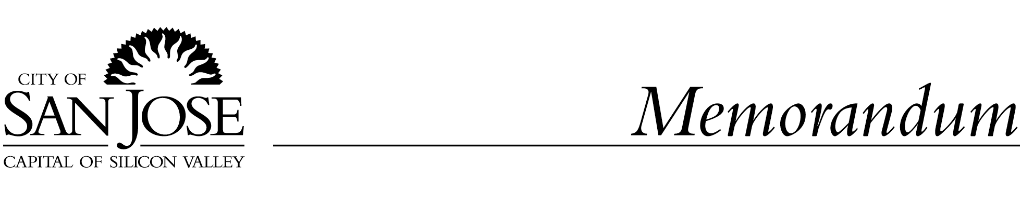
To: HONORABLE MAYOR AND From: Carl W. Mosher
COUNCIL AGENDA: 10-7-03
ITEM:
CITY COUNCIL

Subject: WATERSHED ACTION PLAN Date: 9-17-03

Approved Date

RECOMMENDATION

Adopt a resolution:

- Accepting the Watershed Action Plan as prepared by the Santa Clara Basin Watershed Management Initiative, and

- Authorizing the City Manager to execute the Santa Clara Basin Watershed Management Initiative 2003 Signatory Document, to confirm the City's continued commitment to participate in the Watershed Management Initiative activities.

BACKGROUND

The Watershed Management Initiative (WMI) is a community-based stakeholder process focused on protection and improvement of the Santa Clara Basin Watershed, which encompasses southern San Francisco Bay and the 840 square mile area that drains into the South Bay. There are currently 35 participants in the WMI (“signatory” agencies and organizations), including local, state and federal agencies, trade organizations such as the Silicon Valley Manufacturing Group, the Homebuilders Association, the San Jose Silicon Valley Chamber of Commerce and the Farm Bureau and Cattlemen’s Association, and numerous civic and environmental groups (a list of all current participants is provided in Attachment A).

The Santa Clara Basin was named as one of the Regional Water Quality Control Board’s pilot Watershed Management Initiatives in 1996. Interested stakeholders, including the City, began meeting at that time. After agreeing to its Mission and Goals, the stakeholders determined that it was time to formalize the process and in 1999, developed the “WMI Signatory Document”, a statement of the goals of the WMI and the principles of participation. Each stakeholder organization officially became a participant in the WMI when their governing board approved the Signatory Document. Council approved the Signatory Document in August 1999.

One of the primary goals of the WMI was to have the participants work collaboratively to develop a Watershed Action Plan. The WMI has recently completed this Plan (Attachment B), which is presented for Council acceptance today. Upon acceptance of the Watershed Action Plan, participants in the WMI also recommend that the Signatory Document be updated to reflect completion of the Plan and to affirm the participants’ desire to continue with WMI activities, as the Initiative moves from the planning phase to the implementation phase.

The target date for approval of the revised Signatory Document by all agencies that wish to continue to participate in the WMI is October 31, 2003. The Water District has placed this item on its September 16 agenda for approval and it is on the September 17 agenda for the Regional Water Quality Control Board.

ANALYSIS

Watershed Management Initiative Action Plan

The Watershed Action Plan was approved by representatives of the 35 WMI participants in August 2003. It advocates a comprehensive approach to protection and enhancement of the Santa Clara Basin Watershed. This approach would take the agencies responsible for land use planning and development approval beyond the "smart growth" principles that have recently governed decision making and would emphasize natural flood protection and flood management over construction of flood control works.

The Plan establishes eight "Strategic Objectives" or desired results from the successful implementation of the Plan:

- Incorporate the WMI vision into General Plans and Area Specific Plans;
- Promote drainage systems that detain or retain runoff;
- Integrate multi-use planning of floodplains and riparian corridors;
- Integrate water resource planning;
- Increase and improve the use of Habitat Conservation Plans/Natural Community Conservation Plans;
- Expand the Don Edwards San Francisco Bay National Wildlife Refuge;
- Implement multi-objective stream restoration projects; and
- Improve understanding and control of water pollutants.

The Plan also identifies a wide range of actions that need to be taken by the WMI and various agencies to implement or support the Strategic Objectives. Continued participation by the City in the WMI will result in many of these actions coming back for further Council consideration and allocation of resources in the future. (These actions are identified as “Next Steps” at the end of Chapters 3-9 of the Plan.)
Participants in WMI are currently working on a first-year work plan for implementing the Strategic Objectives of the Watershed Action Plan, discussing its organizational structures and identifying/clarifying linkages with other regional initiatives, such as the Water Resources Protection Collaborative (considered by Council on September 16, 2003), salt pond restoration efforts, and the Santa Clara Valley Urban Runoff Pollution Prevention Program.

WMI participants will now concentrate their efforts on the actions needed to implement the Strategic Objectives by focusing on three general tasks:

- Providing a stakeholder forum for watershed-related issues for the Santa Clara Basin;
- Bringing consensus-based recommendations to decision makers; and
- Providing a forum for watershed outreach and education to encourage public support and action to preserve and enhance the watershed.

Watershed Management Initiative Signatory Document

In addition to recommending acceptance of the Watershed Action Plan, it is recommended that Council confirm the City’s continued commitment to participation in the Watershed Management Initiative activities by authorizing the City Manager to execute the Santa Clara Basin Watershed Management Initiative 2003 Signatory Document.

The original Signatory Document, which the City executed in August 1999, does not cover implementation of the Watershed Action Plan. Execution of the 2003 Signatory Document will commit the City to continued participation in the WMI, including candid discussions about participation in any proposed actions that may be considered. It does not obligate the City to take action on and/or fund any part of the proposed actions. Action items requiring Council approval will still remain discretionary for the Council.

PUBLIC OUTREACH

The Watershed Management Initiative Action Plan was discussed at a series of stakeholder meetings throughout 2002 and 2003. In addition, information was distributed by email to a large mailing list of interested parties and posted on the WMI, City, and District websites. Additional public outreach related to each program will occur as part of implementation as appropriate.

COORDINATION

This memo was coordinated with staff from the Departments of Public Works, Transportation, Parks, Recreation and Community Services, Planning, Building and Code Enforcement and the City Attorney’s Office and the Redevelopment Agency. It has also been coordinated with the appropriate Santa Clara Valley Water District staff.

COST IMPLICATION

There are no cost implications at this time. The budgetary impact of any projects resulting from these agreements will be brought to Council as part of the final adoption of any such agreement.

CEQA

Not a project. Exempt, PP03-09-291.

CARL W. MOSHER
Director, Environmental Services Department

Attachments

